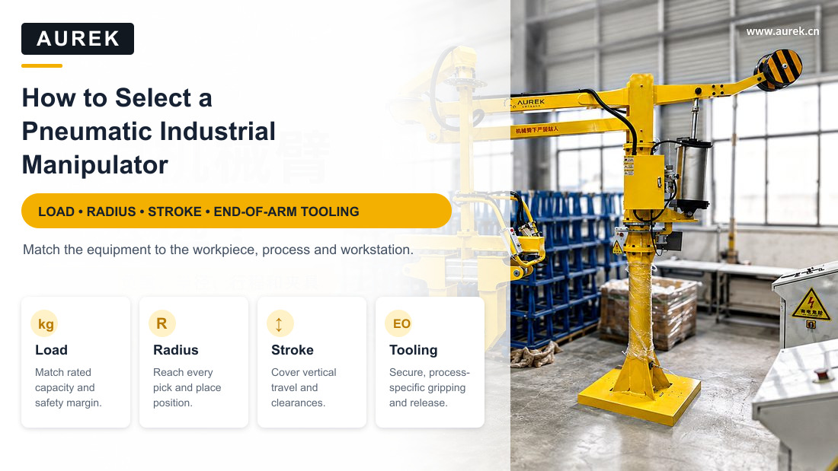

How to Select a Pneumatic Industrial Manipulator
A Practical Guide to Load, Reach, Stroke, Tooling, and Installation
Knowledge Center / Selection Guide · Jiangsu AUREK Intelligent Technology Co., Ltd.
In brief: Select a Pneumatic Industrial Manipulator based on five factors—load, operating radius, lift stroke, end-of-arm tooling, and installation configuration. Load calculations must include workpiece weight, tooling weight, eccentric loading, and a safety margin. The radius must cover the pickup and placement points; stroke is based on the height difference; tooling is customized for the workpiece geometry and surface; and the installation configuration—column-mounted, mobile, or overhead-mounted—is selected for the available site space.

Summary
Selection of a Pneumatic Industrial Manipulator is based primarily on five factors: workpiece load, operating radius, lift stroke, end-of-arm tooling, and installation configuration. Load determines whether the workpiece can be handled stably; radius determines whether the pickup and placement points are within reach; stroke determines whether the vertical range is sufficient; tooling determines whether the workpiece is held securely without damage; and the installation configuration—column-mounted, mobile, or overhead-mounted—is selected for the available site space.
For handling automotive parts, cartons, panels, motor stators, high-temperature castings, tires, and workpieces of 50 kg, 100 kg, or more in machine-loading/unloading applications, Pneumatic Industrial Manipulators are normally custom-engineered for the workpiece weight and dimensions, transfer path, cycle-time requirement, and site conditions.
For more products and cases, see the AUREK official website: https://www.aurek.cn/

1. Which Workstations Are Suitable for a Pneumatic Industrial Manipulator?
A Pneumatic Industrial Manipulator is not merely lifting equipment. It is particularly suited to heavy-material handling, frequent pickup and placement, orientation changes, and assembly assistance in industrial facilities.
Workpieces such as automotive seats, battery-compartment components, motor stators, cartons, panels, and high-temperature castings are often strenuous to handle manually, difficult to position consistently, vulnerable to impact damage, and potentially hazardous. A Pneumatic Industrial Manipulator with custom tooling helps operators handle them with less effort and greater stability.
Suitable Applications | Description
Heavy Workpieces | Manual handling is strenuous, e.g., workpieces of 50 kg, 100 kg, or more
High Handling Frequency | Repeated pickup and placement, machine tending, or assembly throughout the shift
Damage-Sensitive Workpieces | Requires stable clamping, smooth transfer, and gentle positioning
Examples include sheet flipping, automotive seat positioning, and casting pickup | Such as plate flipping, car interior parts flipping, workpiece attitude adjustment
Limited Workstation Space | Manual handling is awkward, and floor-level interference must be reduced
Irregular Workpiece Geometry | Custom gripper jaws, vacuum cups, hooks, or dedicated tooling are required
Flexible Operation Is Required | Multi-station sharing, production line changes or temporary handling tasks

2. Which situations may not be suitable for Pneumatic Industrial Manipulator?
A professional selection process does not recommend one type of equipment for every application. A Pneumatic Industrial Manipulator may not be the first choice in the following situations:
situation | Possibly a more suitable solution
The workpiece is lightweight and already easy to handle manually | Simple tooling or manual operation is sufficient
The transfer distance is particularly long | Conveyor lines, AGVs, and track systems may be more suitable
Motion is fully fixed and the required cycle rate is extremely high | An industrial robot or dedicated automatic machine is more suitable
Only simple vertical lifting is required | A jib crane or intelligent hoist may be more economical
No stable compressed-air supply is available on site | Consider an electric solution or provide an air-supply system

Selection must therefore consider whether the equipment genuinely addresses the site's heavy, hazardous, and repetitive work—not just the equipment itself.

3. First look at the load: not just the weight of workpiece
The first step in selecting a Pneumatic Industrial Manipulator is to determine the required load. This is not limited to the workpiece weight; also consider:
- workpiece maximum weight
- Tooling Weight
- workpiece center of gravity position
- Is the load eccentric?
- Does it need to be flipped?
- handling frequency and usage intensity
- Is it necessary to reserve a safety margin?
For example, if the workpiece weighs 80 kg and the tooling weighs 15 kg, the equipment carries nearly 95 kg. Eccentric loading, flipping motion, and a safety margin must also be considered; selection must not be based on the workpiece's nominal weight alone.
In the standard selection data published on AUREK's website, Pneumatic Industrial Manipulators are classified by rated load as standard-duty or heavy-duty. Standard-duty models are intended for applications below 150 kg; heavy-duty models can cover applications above 150 kg by adding counterweights. The final solution must account for workpiece dimensions and weight, handling cycle time, installation configuration, and workstation design.
A word of caution: Don’t just ask “How many kilograms can this equipment lift at most?” You should also ask “Can this weight be lifted stably, effortlessly, and safely at my work station?”

4. Look at the working radius again: it only makes sense to cover the pick and place points
The operating radius determines the work envelope that the manipulator can cover. Focusing only on load and overlooking reach can result in equipment that can carry the workpiece but cannot reach the pickup point, or that makes placement awkward.
AUREK's published data indicate a conventional operating radius of up to 3500 mm for standard-duty Pneumatic Industrial Manipulators and up to 3000 mm for heavy-duty models. A larger radius is not always better: excessive reach affects operating inertia, structural stability, and site layout. The radius should cover the pickup and placement path while remaining comfortable for the operator.

5. Lifting stroke: look at the height difference, not the height of the equipment
Lift stroke is the effective vertical travel of the end-of-arm tooling. Common applications include:
- Take materials from the floor pallet and place them on the workbench
- Picking a part from a bin and placing it in a machine fixture
- Take cartons from the conveyor line and place them in the stacking area
- Take out workpiece from the equipment and transfer it to the inspection station
- Moving panels, seats, or sheet-metal parts into assembly position
The lifting stroke should not only look at the height of the workbench, but also consider the height of workpiece, height of tooling, grab space and safety margin:
Calculation: lowest pickup height + workpiece height + tooling clearance + safety margin = required lift space.
AUREK's published data indicate a lift stroke of up to 2000 mm for standard-duty Pneumatic Industrial Manipulators and up to 1800 mm for heavy-duty models. The actual solution must still be determined from the site height difference, workpiece dimensions, and tooling structure.

6. Tooling Type: A Key Factor in Usability
The Pneumatic Industrial Manipulator provides the handling force, but end-of-arm tooling often determines whether the system is practical to use. Tooling must be designed for the workpiece geometry, material, surface condition, center of gravity, and required handling motion.
Tooling selection is not simply about whether the workpiece can be gripped. It must be held securely without damage, be easy for the operator to use, and remain serviceable over time.
For example, cartons are usually suited to vacuum gripping; panels may require vacuum gripping plus a flipping mechanism; automotive seats normally require dedicated tooling; motor stators may require a gripper or internal-expansion mechanism; and high-temperature castings require heat-resistant, insulated, and guarded tooling design.
Tooling Type | Suitable Workpieces/Applications
Vacuum-Cup Tooling | Cartons, plates, sheet metal parts, products with smooth surfaces
Mechanical Gripper | Special-shaped parts, metal parts, structural parts
Hook Tooling | Workpieces with holes, lifting points, or attachment points
Internal-Expansion Gripper | Cylindrical parts, inner hole type workpiece, some motor stator products
Flipping Tooling | workpiece requiring 90° or 180° flip
Heat-Resistant Tooling | High-temperature castings, die castings, and heat-treated workpieces
Dedicated Custom Tooling | Custom workpieces with special dimensions, geometry, or orientation

AUREK supports engineered, non-standard solutions ranging from a single tooling assembly to a complete line solution, designed to customer drawings, process requirements, and site conditions.

7. Selecting an Installation Configuration: Column-Mounted, Mobile, or Overhead-Mounted
In addition to load and tooling, installation configuration must be considered. The AUREK ARK series has three principal configurations: ARK-S column-mounted, ARK-M mobile, and ARK-O overhead-mounted.

1. ARK-S Column-Mounted Pneumatic Industrial Manipulator
Suitable for fixed workstations, usually installed through ground fixation or foundation embedded installation. The structure is stable and the floor space is clear. It is suitable for long-term fixed use of handling, loading and unloading and assembly auxiliary scenarios.
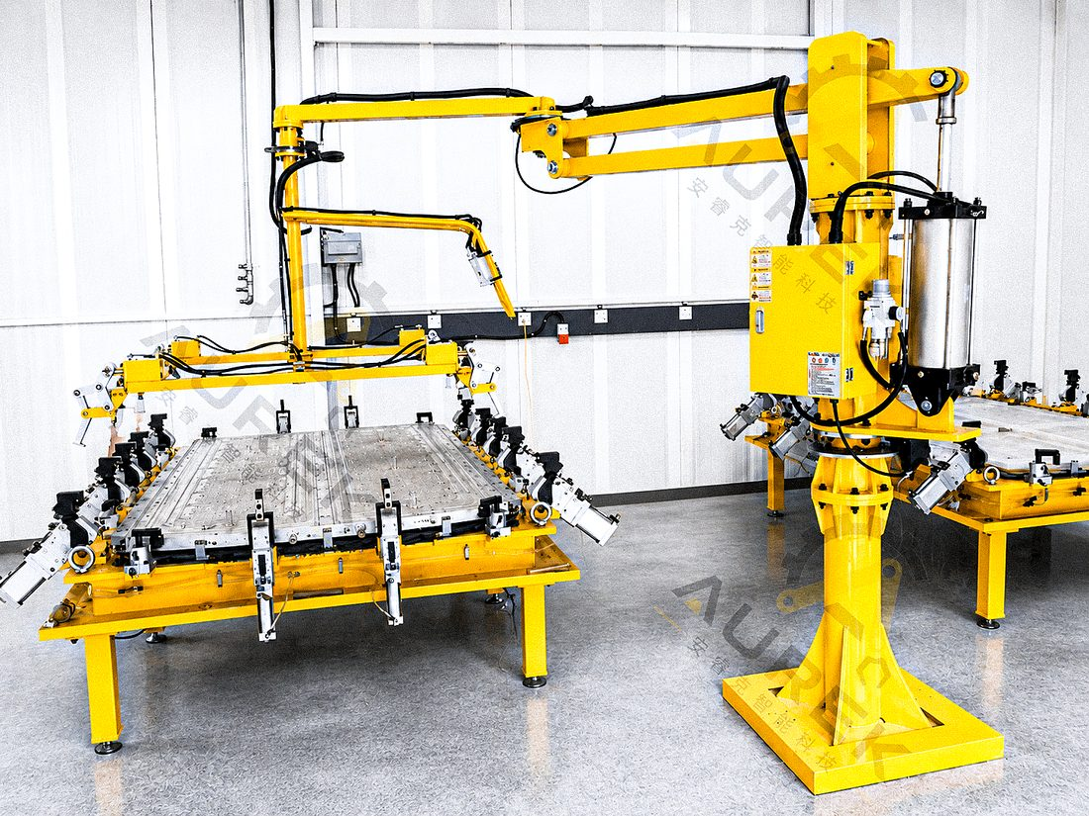
ARK-S Column-Mounted Pneumatic Industrial Manipulator

2. ARK-M Mobile Pneumatic Industrial Manipulator
Suitable for shared use across multiple workstations or lines that are frequently reconfigured. A mobile or counterweighted base allows the equipment to move between workstations for flexible production.
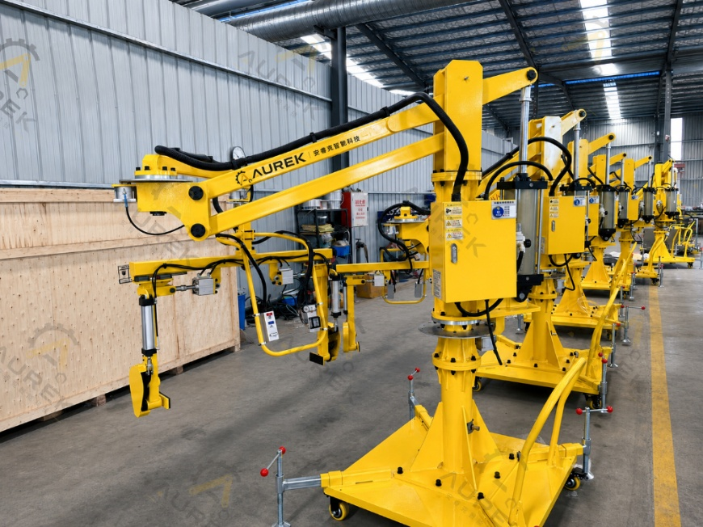
ARK-M mobile Pneumatic Industrial Manipulator

3. ARK-O Overhead-Mounted Pneumatic Industrial Manipulator
Suitable where floor space is limited, equipment is densely arranged, or broad coverage is required. It can be integrated with an overhead steel structure, rail, or gantry system to reduce floor-level interference.
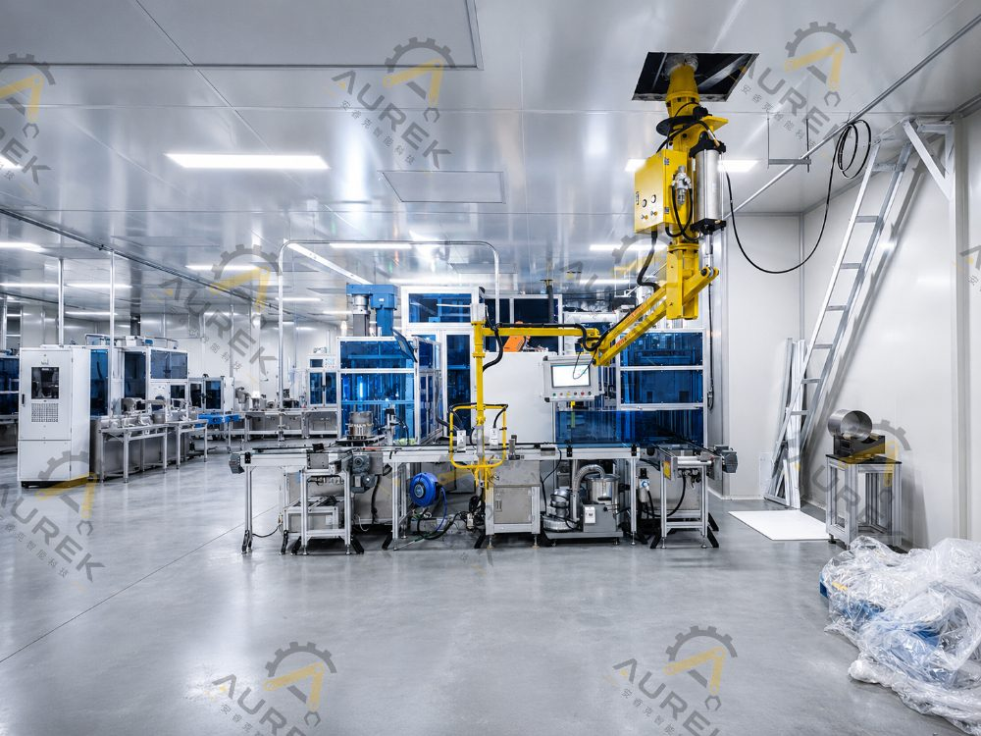
ARK-O Overhead-Mounted Pneumatic Industrial Manipulator
Type | Suitable for the scene | Typical uses
ARK-S Column-Mounted | Fixed workstation, fixed loading and unloading, assembly assistance | Machine loading/unloading, workpiece handling, and assembly positioning
ARK-M mobile | Multi-station sharing, production line adjustment, temporary handling | Flexible production, multi-point pick and place, work station switching
ARK-O Overhead-Mounted | Tight ground space, dense equipment, and large coverage | Track handling, cross-station transfer, loading and unloading assistance

8. Preliminary Selection Reference
The following parameters are intended for preliminary selection. Final values must be confirmed for the workpiece, tooling, required cycle time, and site conditions.
Selection Parameter | Reference content
Rated load | Standard-duty models are suitable for loads below 150 kg; heavy-duty models can cover applications above 150 kg
Working radius | Based on pickup and placement distance, required clearances, and travel path
Lift stroke | Based on the lowest pickup point, highest placement point, workpiece height, and tooling clearance
Drive mode | Select pneumatic or electric drive to suit the operating conditions
Installation method | Column-mounted, mobile, or overhead-mounted
end-effector tooling | Vacuum cups, grippers, hooks, flipping tooling, or dedicated custom tooling
Air supply conditions | For a pneumatic solution, confirm that a stable compressed-air supply is available on site
Usage environment | Consider temperature, humidity, dust, high-temperature exposure, hazardous-area requirements, and cleanliness

General parameters published on AUREK's website: rated operating air pressure 0.5–0.7 MPa (5–7 bar), operating temperature −15 to 50 °C, relative humidity <90%, and pneumatic or electric drive options.

9. Three typical selection scenarios
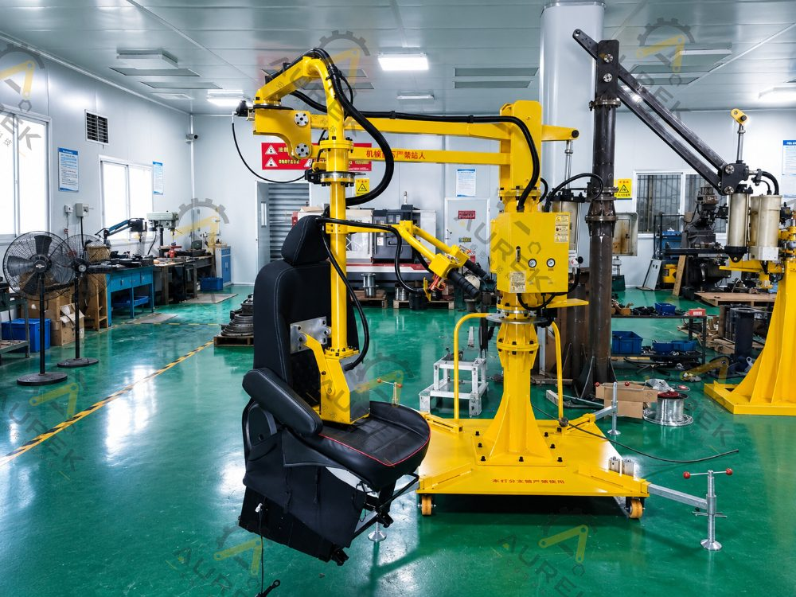
Typical Applications for Pneumatic Industrial Manipulators

Scene 1: Car seat handling
Automotive seat assemblies often have irregular geometry and an offset center of gravity. Manual handling is strenuous and can compromise assembly positioning. A Pneumatic Industrial Manipulator with dedicated seat tooling can support gripping, lifting, horizontal transfer, and assisted assembly. Key selection considerations:
- Is the workpiece center of gravity offset?
- Is assembly alignment required?
- Will tooling crush the seat surface?
- Do you need mobile equipment to accommodate multiple workstations?
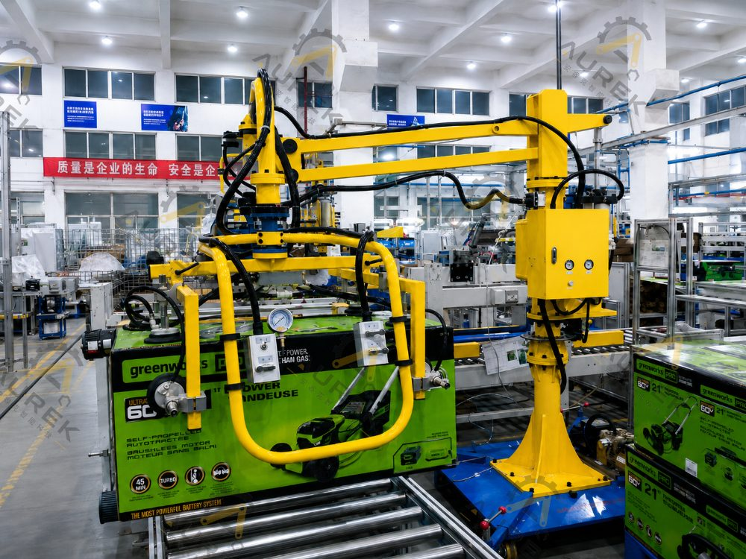
Car seat handling application

Application 2: Carton or Box Handling
Cartons and box-shaped products usually have regular surfaces, making vacuum-cup tooling a practical option. Compared with repeated manual bending and lifting, vacuum handling reduces repetitive effort and is suitable for packing, case packing, transfer, and stacking stations. Key selection considerations:
- Is the surface of the carton flat?
- Is the box easily deformed?
- Is the frequency of handling higher?
- Is mobile equipment required for flexible switching between workstations?
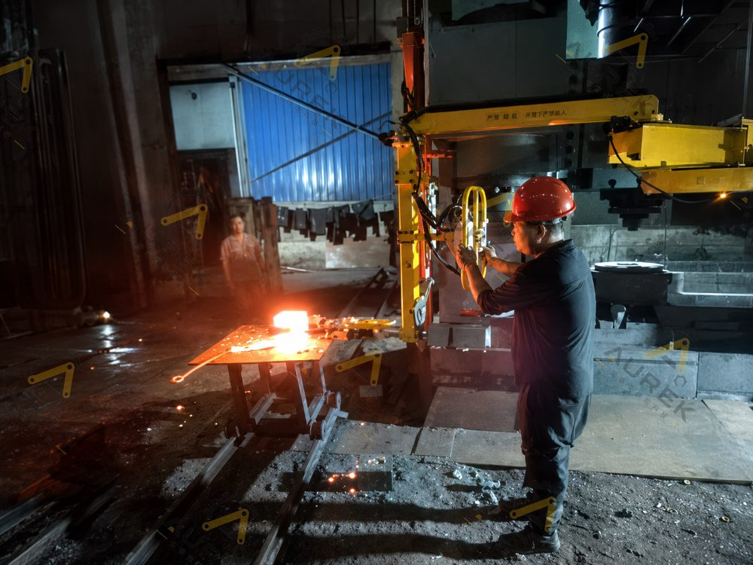
Carton / Box handling Application

Application 3: High-Temperature Casting Handling
High-temperature casting handling requires consideration of not only weight, but also thermal insulation, safeguards, and personnel safety. These applications normally require heat-resistant tooling, thermal barriers, or cooled pneumatic-circuit design to reduce close operator exposure to heat sources. Key selection considerations:
- workpiece temperature range
- Is tooling material temperature resistant?
- Do pneumatic components need protection?
- Safe distance between operator and heat source

10. Information to Prepare Before Requesting a Manipulator Solution
In order to judge the solution faster, it is recommended to prepare the following information before consultation:
Information | Description
Workpiece Photographs or Video | Used to determine the shape, gripping surface and operating posture of workpiece
workpiece weight | Includes maximum and regular weights
workpiece size | Length, width, height, center of gravity, and whether the geometry is irregular
handling action | Do you need to lift, rotate, flip or translate?
Pick and place location | Pickup point, placement point, height difference, and distance
On-site environment | Floor space, overhead structure, surrounding equipment, and access routes
Frequency of use | handling times per hour, working hours per day
energy conditions | Availability of compressed air and electrical power, and whether electric assist is required
special request | High-temperature, hazardous-area, cleanliness, scratch-prevention, or deformation-prevention requirements

For non-standard workpieces, provide site video, workstation photographs, or workpiece drawings so engineers can assess the manipulator structure, tooling type, installation configuration, and control logic more accurately.

11. Summary: Five Factors in Manipulator Selection
Load determines whether the workpiece can be carried; radius determines whether the required points are within reach; stroke determines whether the vertical travel is sufficient; tooling determines usability; and installation configuration determines whether the solution can be implemented on site.
For a fixed workstation, consider a column-mounted configuration first. For shared use across multiple workstations, consider a mobile configuration. Where floor space is limited or equipment is densely arranged, consider an overhead-mounted or rail-mounted solution.
For a heavy, irregular, damage-sensitive, or flipped workpiece, or a complex site layout, purchasing only standard equipment is not recommended. Develop a custom solution for the workpiece and site.
AUREK can provide customized solutions around Pneumatic Industrial Manipulator, custom tooling, vacuum gripping, jib crane and industrial handling systems. For more information, see the official website: https://www.aurek.cn/

Frequently Asked Questions
1. Can a Pneumatic Industrial Manipulator handle workpieces over 100 kg?
Yes. The solution depends on workpiece weight, dimensions, center of gravity, tooling weight, operating radius, and site conditions. For workpieces over 100 kg, selection normally requires an integrated review of workstation layout, transfer path, and tooling structure.
2. Is a larger manipulator always better?
No. Load, radius, and stroke must match the workstation. Excessive radius can affect operating inertia and stability; appropriate coverage of the pickup and placement path is more important.
3. What if the workpiece has no regular gripping surface?
Grippers, internal-expansion tooling, hooks, form-fitting tooling, or hybrid tooling can be used. Tooling for irregular parts is normally customized from workpiece drawings and the required site motions.
4. Can the manipulator flip a workpiece?
Yes. Flipping capability depends on the workpiece center of gravity, tooling structure, and control method. Common functions include 90° flipping, 180° flipping, and orientation adjustment.
5. Can Pneumatic Industrial Manipulator be used without air supply?
If no stable compressed-air supply is available, consider an electric-drive solution or provide an air-supply system. The appropriate choice depends on load, cycle time, operating environment, and available site utilities.
6. How do I choose among column-mounted, mobile, and overhead-mounted configurations?
For a fixed workstation, prioritize a column-mounted configuration. For shared use across multiple workstations or a frequently reconfigured line, consider a mobile configuration. Where floor space is limited, equipment is densely arranged, or broad coverage is required, consider an overhead-mounted configuration.
7. What is the difference between a Pneumatic Industrial Manipulator and a jib crane?
A jib crane is primarily intended for conventional lifting. A Pneumatic Industrial Manipulator emphasizes human-guided operation, load balancing, orientation control, and custom end-of-arm tooling, making it better suited to precise pickup and placement, flipping, and assembly assistance.
8. How do I choose between a Pneumatic Industrial Manipulator and an industrial robot?
A Pneumatic Industrial Manipulator is better suited to human-guided operation, low-effort handling of heavy loads, flexible workstations, and custom-tooling applications. Industrial robots are better suited to fixed cycle times, repetitive motion, and high levels of automation.

