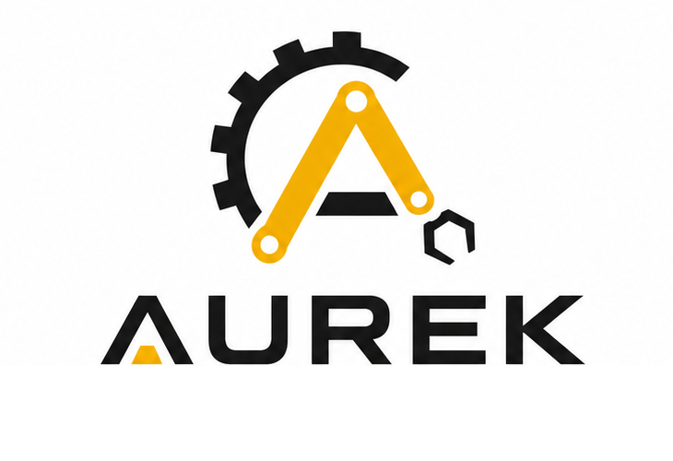
Pneumatic Industrial Manipulator
Operation Manual
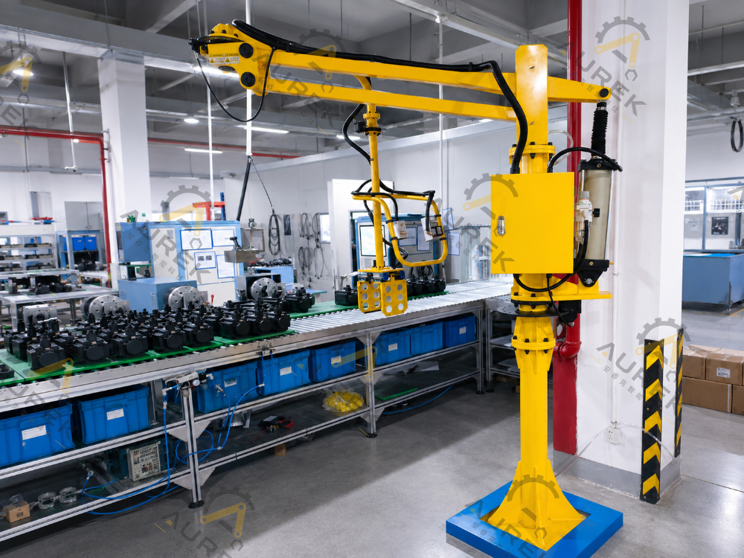
Figure 1. Example of a Column-Mounted Pneumatic Industrial Manipulator (actual structure per project drawings)
Document No. | AUREK-OM-ARK-001
Version/Date | V1.1 / 2026-06
Applicable Products | ARK-Series Pneumatic Industrial Manipulators and Custom Tooling
Manufacturer | Jiangsu AUREK Intelligent Technology Co., Ltd.
Official website | www.aurek.cn
Read this manual in full before installation, commissioning, operation, or maintenance, and retain it for future reference.

0. Document Information and Equipment Details
This is the general operation manual for AUREK Pneumatic Industrial Manipulators and applies to custom column-mounted, mobile, overhead-mounted, and similar configurations. Because the manipulator, tooling, installation configuration, and control logic are customized for the customer's workpiece and site conditions, refer to the contract, final drawings, equipment nameplate, pneumatic schematic, electrical schematic, and acceptance documents for the actual configuration.
Important Information
Any operation not expressly permitted by this manual shall be considered prohibited.
Exceeding the rated load, making unauthorized changes to pneumatic/electrical circuits or the structure, or bypassing a safety device may cause equipment damage or personal injury.

0.1 Version History
Version | Date | Revision Details | Prepared/Approved By
V1.1 | 2026-06 | Standardized structural-component terminology, parameter descriptions, safety requirements, maintenance and inspection items, troubleshooting content, and formatting; added a structural diagram and numbered reference table. | Engineering/After-Sales Service

0.2 Equipment Nameplate and Project Record
Equipment Model | Fill in the content | Serial No. | Fill in the content
Project No. |  | Rated Load
□ Column-mounted □ Mobile □ Overhead-mounted □ Other |  | Factory number
Rated load | kg | Maximum working radius | mm
Lift stroke | mm | Air supply pressure | MPa
tooling type |  | Installation method | □ Column-mounted □ Mobile □ Overhead-mounted □ Other
Delivery date |  | After-sales contact

Contents
0. Document Information and Equipment Details 2
0.1 Version History 2
0.2 Equipment Nameplate and Project Record 2
1. Safety Instructions 4
1.1 Warning Levels 4
1.2 Prohibited Practices 4
1.3 Personal Protective Equipment and Site Requirements 4
2. Product Overview 5
2.1 Intended Applications 5
2.2 ARK-Series Installation Configurations 5
2.3 Engineered Delivery Process 5
3. Structure and Main Components 6
3.1 Operating Principle 7
3.2 Tooling-to-Machine Interface 7
4. Technical Data and Selection 8
4.1 General Selection Data 8
4.2 Standard and Optional Features 8
4.3 Information Required Before Selection 8
5. Transport, Storage, and Unpacking Inspection 9
5.1 Transport and Storage 9
5.2 Unpacking Inspection 9
6. Installation and Commissioning 10
6.1 Pre-Installation Preparation 10
6.2 Column-Mounted Foundation Requirements 10
6.3 Overhead-/Rail-Mounted Installation Requirements 10
6.4 Commissioning Procedure 10
7. Operating Procedures 11
7.1 Pre-Start Inspection 11
7.2 Typical Operating Sequence 11
7.3 Control Functions 11
7.4 Unloaded- and Loaded-Balance Adjustment 12
8 Maintenance and inspection 13
8.1 Routine Maintenance 13
8.2 Detailed Equipment Inspection Checklist 13
8.3 Lubrication and Air-Supply Requirements 14
9. Troubleshooting 15
9.1 Basic Troubleshooting Requirements 15
9.2 Common Faults, Causes, and Corrective Actions 15
10. Decommissioning, Relocation, and Disposal 16
10.1 End-of-Shift Shutdown 16
10.2 Long-Term Shutdown 16
10.3 Relocation and Disposal 16
Appendix A. Contact and Service 17

1. Safety Instructions
Improper operation may cause an accident. This equipment must be operated, maintained, and serviced only by trained and qualified personnel. Operators must understand site hazards, rated equipment parameters, tooling action logic, and emergency shutdown/unloading procedures.
SPECIAL WARNING
Never connect or disconnect the air supply, close the air-supply shutoff valve, or make unauthorized pneumatic-circuit adjustments while the equipment is operating, gripping a workpiece, or supporting a suspended load.
Before restoring the air supply/electrical power, you MUST confirm that the tooling is at its lowest safe position and is not gripping a workpiece. The tooling may move suddenly when the air supply/electrical power is restored.

1.1 Warning Levels
Signal Word | Meaning | Potential Consequences | Required Action
DANGER | An immediate, severe hazard exists. | May result in serious injury, death, or major equipment damage. | Stop work immediately. Do not continue until the hazard has been eliminated.
WARNING | A significant hazard or risk of incorrect operation exists. | May result in personal injury or equipment damage. | Follow the specified procedure strictly; contact the manufacturer when necessary.
CAUTION | A condition may affect stable equipment operation or service life. | May result in minor injury, product damage, or malfunction. | Inspect, maintain, and document as required.

1.2 Prohibited Practices
No. | Prohibited Practice | Risk
1 | Never overload the equipment or lift a workpiece that exceeds the rated load on the equipment nameplate. | Overloading may cause failure of the arms, cylinder, connections, or tooling.
2 | Personnel must not stand or pass beneath the load or main arm, or within the tooling travel path. | Unexpected descent or swinging of the load or tooling may cause personal injury.
3 | Never leave a suspended load unattended. | Air-supply fluctuations, incorrect operation, or tooling leakage may cause the load to fall.
4 | Do not make unauthorized modifications to pneumatic circuits, valve manifolds, regulators, end stops, brakes, or tooling structures. | Doing so may compromise balance control and loss-of-air protection.
5 | Do not weld, cut, strike, or forcibly drag a suspended load. | Doing so may cause structural damage, load swing, or tooling failure.
6 | Keep hands, clothing, and tools away from rotating joints, gripper jaws, cylinders, and other moving parts. Never reach into these areas. | Contact may cause pinching, entanglement, or component damage.

1.3 Personal Protective Equipment and Site Requirements
- Personnel performing installation, commissioning, or maintenance MUST wear the required personal protective equipment, including a hard hat, safety footwear, and protective gloves.
- Provide clear access routes, safety labels, and necessary guarding or segregation around the work area. The floor must be free of significant oil contamination, standing water, and obstructions.
- Do not operate the equipment at night or in poorly lit areas. The operator must continuously monitor the workpiece and tooling.
- Compressed air must be clean, dry, and stable. The air supply must not contain oil, water, contaminants, or corrosive gases.
- Personnel who are unwell, have consumed alcohol, or have taken medication that impairs judgment must not operate the equipment.

2. Product Overview
AUREK Pneumatic Industrial Manipulators are used for industrial workpiece handling, machine loading/unloading, assembly assistance, flipping and positioning, and transfer between workstations. Pneumatic balancing, rigid arms, and custom tooling work together to reduce manual-handling effort and improve handling stability and workstation efficiency.

2.1 Intended Applications
- Suitable for handling workpieces of 50 kg, 100 kg, or more, and for production tasks that require reduced manual support, lifting, carrying, flipping, or alignment effort.
- Typical industries include auto parts, new energy batteries, general manufacturing, logistics handling, electronics manufacturing, aerospace, etc.
- Typical workpieces include automotive seats, sheet-metal parts, headliner trim, motor stators, cartons/enclosures, panels, tires, high-temperature castings, and roller products.
- End-of-arm tooling can be customized for workpiece geometry, weight, surface condition, gripping surface, and motion path. Examples include vacuum cups, grippers, hooks, internal-expansion grippers, and inflatable shafts.

2.2 ARK-Series Installation Configurations
Series | Installation Configuration | Suitable Applications | Main Features
ARK-S | Column-Mounted / Floor-Fixed | Fixed-workstation handling, machine loading/unloading, and assembly assistance. | Stable structure with a clearly defined footprint; customizable for workpiece weight, radius, and path.
ARK-M | Mobile / Counterweighted Base | Shared use across multiple workstations, frequently reconfigured lines, and temporary workstations. | Can be moved manually or with electric assist; suitable for flexible production.
ARK-O | Overhead-Mounted / Ceiling-Fixed / Rail-Mounted | Applications with limited floor space, dense equipment layouts, or a large coverage area. | Saves floor space and can be integrated with a gantry or rail system.

2.3 Engineered Delivery Process
Stage | Core Activities | Deliverables/Approval Points
Analysis | Confirm workpiece weight, dimensions, gripping surfaces, cycle time, motion path, site space, air-supply conditions, and safety risks. | Requirements list, site-survey record, and preliminary solution.
Design | Develop the structural concept, tooling concept, pneumatic-control logic, 3D CAD design, simulation verification, and any required prototype review. | Concept drawings, 3D models, pneumatic/electrical design, and quotation scope.
Review | Confirm workpiece compatibility, operating method, installation configuration, maintenance space, safeguards, and acceptance criteria with the customer. | Approved drawings, technical agreement, and review record.
Production | Fabrication and assembly, pneumatic installation, factory testing, packaging and shipment, on-site installation and commissioning, and training. | Factory inspection record, acceptance form, operation manual, and maintenance record form.

3. Structure and Main Components
A Pneumatic Industrial Manipulator normally consists of a base/column, rotary joints, main arm, secondary arm, lift cylinder, air receiver, pneumatic control enclosure, control handle, brakes, tooling interface flange, and custom tooling. Arm length, number of joints, brake type, tooling structure, and pneumatic-control logic are adapted to site conditions for each project.
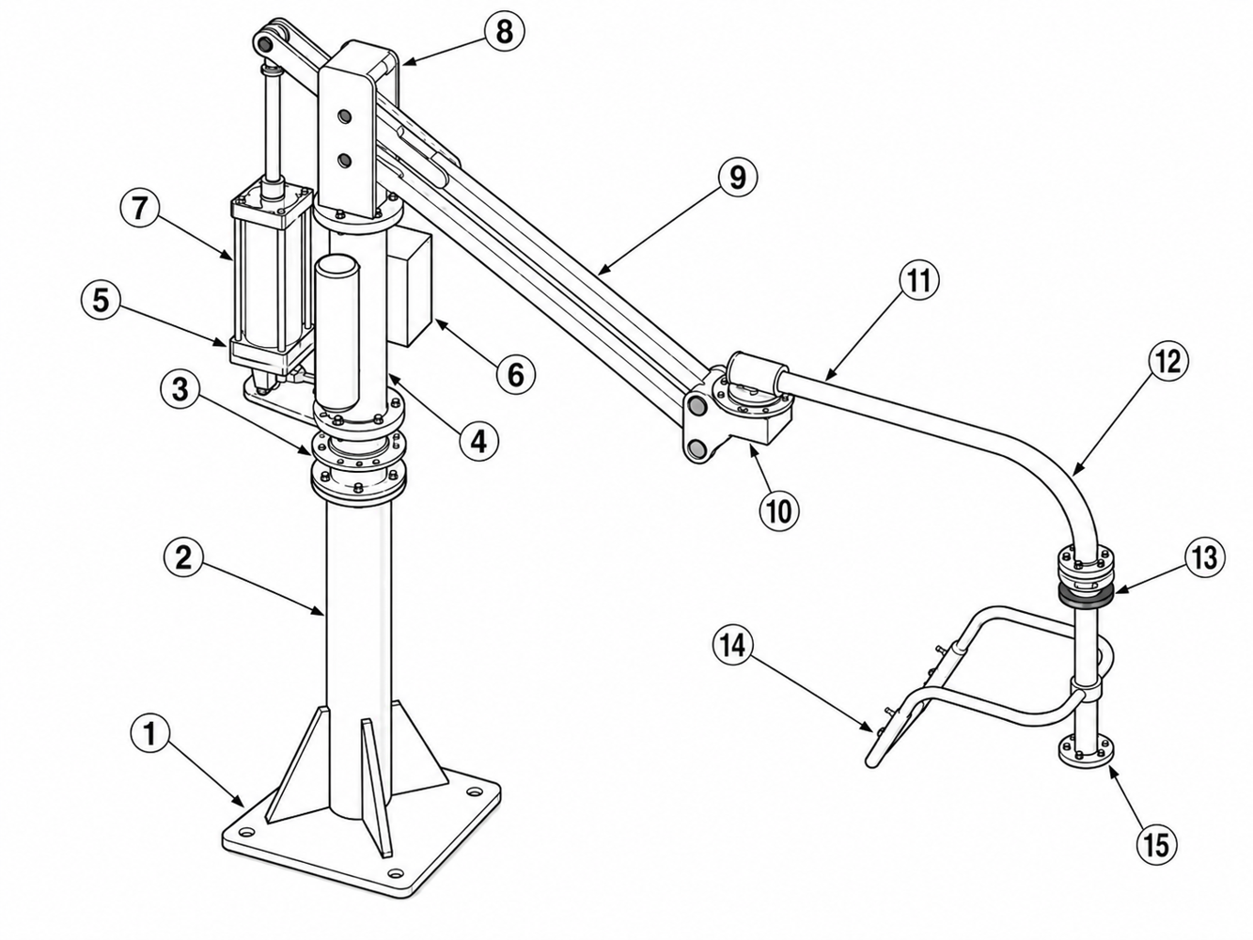
Figure 2. Pneumatic Industrial Manipulator Structure (numbers correspond to the table below; actual equipment may vary)
No. | Component | Function
1 | Fixed Mounting Base | Secures and supports the complete equipment assembly to ensure stable manipulator installation. Depending on the project, the equipment may be floor-mounted, installed on a mobile base, or connected to a steel structure.
2 | Load-Bearing Column | Supports the complete equipment weight and provides the supporting structure for the upper rotary assembly, arms, and pneumatic system.
3 | Main Rotary Joint | Allows the manipulator to rotate horizontally, extending the workpiece pickup and placement coverage area.
4 | Lower Lift-Cylinder Support | Secures the lower end of the lift cylinder, maintains stable cylinder loading, and provides a reliable connection to the arm mechanism.
5 | Safety Air Receiver | Provides a reserve of compressed air during air-supply fluctuations or a brief loss of air, helping the equipment unload safely or descend slowly.
6 | Pneumatic Control Enclosure | Houses the principal pneumatic-control components, pressure-regulation components, and protection modules for convenient commissioning, maintenance, and fault inspection.
7 | Lift Cylinder | Provides vertical assist for unloaded/loaded balance and raising/lowering motion.
8 | Main-Arm Support | Connects the column to the main arm, carries main-arm motion loads, and provides the main arm's mounting and load-support point.
9 | Main Arm | Carries handling motion within the principal operating radius and is the main structure that defines horizontal coverage.
10 | Intermediate Rotary Joint | Connects the main arm and secondary arm, enabling multi-angle steering and flexible pickup and placement.
11 | Secondary Arm | Extends the operating range and improves access to workpieces and flexibility when transferring between workstations.
12 | Front Rotary Joint | Connects the front-end actuation structure and supports tooling-direction adjustment, orientation control, and workpiece positioning.
13 | Front Connection Arm | Connects the control handle, front joint, and tooling interface for compatibility with different end effectors.
14 | Control Handle | Held by the operator to control raising, lowering, gripping, release, flipping, braking, and other equipment functions.
15 | Tooling Interface Flange | Connects custom tooling and end effectors such as vacuum cups, hooks, grippers, and internal-expansion mechanisms.

3.1 Operating Principle
The equipment uses pneumatic balancing and a lever mechanism. The cylinder applies a balancing force to the load through the force arm, while a precision regulator sets and stabilizes cylinder pressure so the operator can raise, lower, translate, steer, and position the load with low operating force. Control logic switches between unloaded and loaded states; loss-of-air protection, joint brakes, and tooling interlocks reduce the risk of unintended movement.

3.2 Tooling-to-Machine Interface
- Tooling design must match the workpiece center of gravity, gripping surface, surface material, allowable indentation, handling motion, and cycle time.
- Vacuum tooling must include a vacuum generator/vacuum pump, vacuum gauge or vacuum switch, filter, and any required loss-of-vacuum protection.
- Mechanical gripper tooling requires confirmation of gripping force, contact materials, slip and damage prevention, end stops, gripped-position feedback, and release interlocks.
- For high-temperature workpiece tooling, evaluate thermal-insulation materials, air-tubing temperature rating, personnel safety distance, and the effect of nearby heat sources.
- Tooling may be replaced, removed, or installed only after the workpiece has been unloaded, the air supply/electrical power shut off, residual pressure released, and the absence of motion hazards confirmed.

4. Technical Data and Selection
Selection Limits
The following table provides general selection guidance. AUREK equipment is custom-engineered; final load, radius, stroke, tooling, installation configuration, drive type, and safety provisions are subject to the project drawings, nameplate, and acceptance documents.

4.1 General Selection Data
Parameter | Standard-Duty | Heavy-Duty / Counterweighted | Description
Rated Load | ＜150 kg | ≥150 kg | Confirm from workpiece weight, tooling weight, eccentric loading, and the safety factor.
Standard Operating Radius | ≤3500 mm | ≤3000 mm | May be adapted to site space, travel paths, and load.
Standard Lift Stroke | ≤2000 mm | ≤1800 mm | Actual stroke depends on installation height, tooling length, and workpiece orientation.
Rated Operating Air Pressure | 0.5–0.7 MPa | 0.5–0.7 MPa | A stable supply of clean, dry compressed air and a filter-regulator are recommended.
Operating Temperature | -15–50 ℃ | -15–50 ℃ | High-temperature, low-temperature, cleanroom, hazardous-area, and other special applications require dedicated engineering.
Relative Humidity | ＜90% | ＜90% | Avoid prolonged exposure to condensation, corrosive gases, and dust.
Drive Type | Pneumatic or Electric | Pneumatic or Electric | Pneumatic balancing is standard; special cycle-time or operating requirements can be engineered to order.

4.2 Standard and Optional Features
Category | Feature | Description
Standard | Multiple Rotary Joints | Provides pickup and placement over a broad area and supports transfer and positioning between workstations.
Standard | Joint Brakes | Brakes/end stops can be provided as required at the main, intermediate, and front joints.
Standard | Backup Air Supply / Air Receiver | Provides reserve air if the main air supply is interrupted, allowing the force arm to descend slowly or complete a safe unload.
Standard | Protective Enclosure / Pneumatic Control Enclosure | Protects precision pneumatic components and simplifies maintenance.
Optional | Extended/Widened Arm | Extends the operating radius or clears equipment interference.
Optional | Lift End Stop / Loss-of-Air Brake | Improves safety at travel limits and under loss-of-air conditions.
Optional | Counterweights / Counterweighted Base | For heavy loads, mobile bases, or tooling with an eccentric load.
Optional | Special Coating / Stainless-Steel Structure | For clean, humid, corrosive, or brand-color-specific applications.
Optional | Air Compressor / Mobile Base | For insufficient on-site air supply or flexible use across multiple workstations.

4.3 Information Required Before Selection
Category | Information to Confirm
Workpiece Information | Weight, dimensions, center of gravity, material, surface condition, permitted gripping/vacuum points, and susceptibility to deformation.
Motion Requirements | Pickup and placement heights, transfer distance, flipping angle, rotation direction, cycle time, and required positioning accuracy.
Site Information | Space around the equipment, aisle width, foundation conditions, overhead steel structure, air/electrical supply, temperature and humidity, dust, and oil contamination.
Safety Information | Personnel traffic areas, hazards beneath the load, emergency-stop/brake requirements, tooling loss-of-pressure protection, and secondary restraints.
Delivery Information | Site access route, installation window, acceptance criteria, intended trainees, spare parts, and maintenance plan.

5. Transport, Storage, and Unpacking Inspection

5.1 Transport and Storage
- Do not stack product packages more than three high. Do not climb or stand on packages or place heavy objects on them.
- During transport, do not overturn the tooling, subject it to severe impact, leave it tilted for prolonged periods, or apply abnormal external forces to it.
- Protect packages from moisture, direct sunlight, rain, and corrosive-gas environments.
- For long-term storage, keep the equipment dry and ventilated and protect critical moving parts against corrosion, dust, and impact.
- Before returning the equipment to service, complete the Pre-Start Inspection and Maintenance Inspection Checklist.

5.2 Unpacking Inspection
Inspection Item | Inspection Details | Corrective Action
Product Identification | Verify the equipment model, customer project, drawing revision, and nameplate data. | If the model does not match, stop installation and contact AUREK.
Appearance and Structure | Inspect the arms, column, base, cylinder, pneumatic control enclosure, and tooling for shipping damage. | Record photographs and assess the extent of damage before taking corrective action.
Accessories | Verify that fasteners, air tubing, fittings, the filter-regulator, documentation package, and spare parts are complete. | Supply missing items in accordance with the packing list.
Drawings and Documentation | Verify the operation manual, pneumatic schematics, electrical schematics, acceptance records, certificates, and other documents. | Missing documents must be supplied before the equipment is released for use.

6. Installation and Commissioning
Installation Responsibility
Installation, relocation, foundation reinforcement, overhead suspension, and rail/gantry connections MUST be performed by qualified professionals. The equipment must not enter production before installation is complete.

6.1 Pre-Installation Preparation
- Confirm that the foundation, steel structure, or mobile base has sufficient capacity for the equipment and dynamic loads.
- Confirm that site air-supply pressure, flow, line diameter, filtration, and drying capacity meet the equipment requirements.
- Confirm that the installation area is free of obstructions and that the rotation radius has no fixed interference points or personnel-traffic hazards.
- Clean and decontaminate bearings, rollers, rotary connections, pins, bolts, and other kinematic pairs; lubricate as required and check fastener tightness.
- Install in accordance with the general arrangement drawing, foundation drawing, pneumatic schematic, electrical schematic, and approved project drawing.

6.2 Column-Mounted Foundation Requirements
Column-mounted manipulators are generally secured to the foundation with expansion anchors or chemical anchors. The standard recommendation is a concrete thickness of at least 200 mm and a strength grade of at least C25. If the site foundation is inadequate, embedded-anchor or reinforcement design must be completed by qualified professionals.
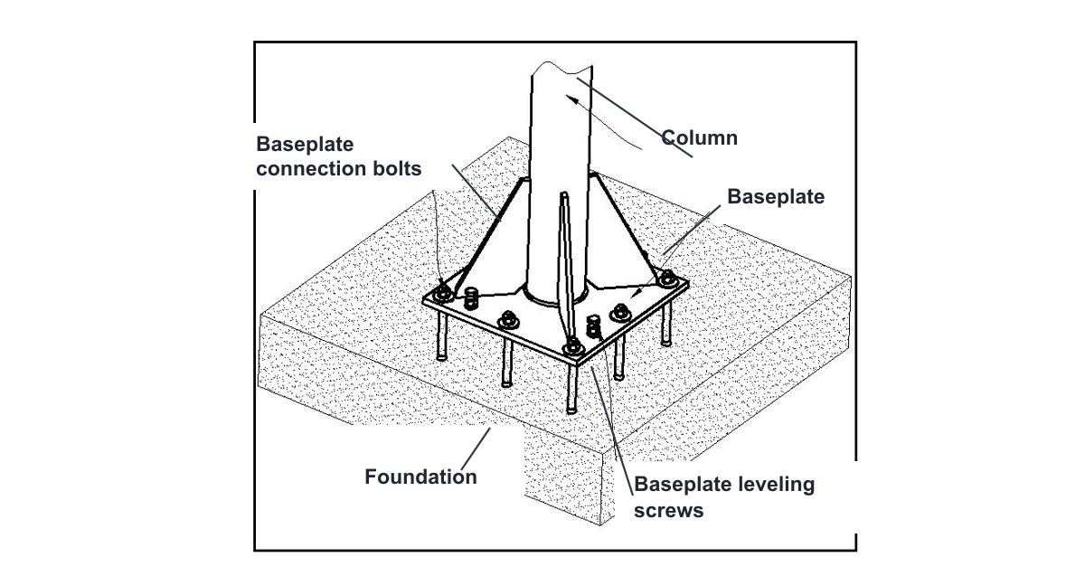
Figure 3. Column-Mounted Foundation Installation (reference only; project foundation drawing governs)

6.3 Overhead-/Rail-Mounted Installation Requirements
- The overhead steel structure, gantry, rails, lifting points, and connections must be verified for load capacity. Do not attach the equipment directly to an unverified lightweight roof or non-load-bearing member.
- Provide mechanical end stops and anti-drop devices at rail ends, and safety buffers at both ends of the travel range.
- After installing overhead-mounted equipment, verify the lowest point, highest point, personnel clearance height, and interference with surrounding equipment.
- All work at height MUST comply with site regulations for working at height.

6.4 Commissioning Procedure
Step | Action | Acceptance Criterion
1 | Inspect all load-bearing bolts, pins, flanges, cylinder connections, and tooling connections. | All fasteners are secure, with no looseness, cracks, or abnormal deformation.
2 | Connect a supply of clean, dry compressed air and slowly open the main air-supply valve. | The filter-regulator reads normally and the pneumatic circuit has no obvious leaks.
3 | Adjust unloaded-balance pressure with no load attached. | The arms raise and lower easily without unintended rapid upward or downward movement.
4 | After gripping a test workpiece, switch to the loaded state and adjust loaded balance. | The load remains stably balanced/suspended, operating force is low, and the tooling does not slip.
5 | Test raising/lowering, rotation, brakes, pickup, release, flipping, and other functions. | The action sequence is correct, and end stops and interlocks operate effectively.
6 | Complete a full handling-cycle test at the actual workstation. | No interference or abnormal noise, and no pulling or kinking of air tubing.
7 | Provide and document safety training for operators. | Operators understand prohibited practices, daily inspection, and troubleshooting procedures.

7. Operating Procedures
Pre-Operation Check
The first operator on each shift MUST complete the pre-start inspection. If abnormal noise, an air leak, rough motion, loose tooling, a cracked weld, insufficient air pressure, or brake failure is found, remove the equipment from service immediately and report the condition.

7.1 Pre-Start Inspection
Inspection Item | Acceptance Check
Air Supply | Pressure meets project requirements and the compressed air is clean and dry. Condensate in the filter-regulator bowl is below the level mark.
Load-Bearing Connections | Base, column, arms, cylinder, flange, and tooling connections have no looseness, cracks, or deformation.
Air Tubing/Cables | No bulges, cracks, kinks, or wear, and no interference with rotary joints or moving parts.
Tooling | Gripper jaws, vacuum cups, hooks, and internal-expansion elements are undamaged; gripping surfaces are clean; fasteners are secure.
Brakes/End Stops | Joint brakes, lift end stops, mechanical end stops, and interlocks function correctly.
Work Area | The load path is free of personnel, obstructions, and unsecured items; the floor is clean.

7.2 Typical Operating Sequence
Step | Operation | Precautions
1 | Open the main air supply and confirm that the pressure gauge/indicator is within its normal range. | Do not open the valve abruptly. If abnormal leakage occurs, close it immediately.
2 | Move the unloaded manipulator to the pickup position. | Keep both hands on the control handle or in the specified positions, clear of joint pinch points.
3 | After confirming correct contact between the tooling and workpiece, perform the pickup operation. | For vacuum tooling, confirm that the required vacuum level has been reached; for a gripper, confirm that it is fully closed.
4 | Switch to the loaded-balance/Load state. | Do not press Load when no workpiece is present. Do not move rapidly until the load is stable.
5 | Raise, lower, rotate, transfer, flip, or position at a smooth, controlled speed. | Keep the workpiece in view at all times. Never move a load over personnel.
6 | At the placement position, seat the workpiece securely and remove the supported load from the manipulator. | Release the tooling only after the workpiece is fully supported and stable.
7 | Release the tooling and confirm that the workpiece is secure; return unloaded or move to the parking position. | At the end of the shift, lower the tooling to its lowest safe position and shut off the air supply.

7.3 Control Functions
Control names and quantities vary by tooling type, flipping mechanism, and interlock method. Typical controls are listed below. The labels on the actual equipment and the pneumatic/electrical schematics take precedence.
Control | Function | Operating Precautions
Brake Knob/Button | Engages or releases the brake at the column, main joint, or designated joint. | Before moving, confirm that the brake is released; lock it as required when parked.
Pickup/Grip | Actuates gripper clamping, vacuum gripping, or the internal-expansion mechanism. | You MUST confirm that the workpiece is correctly positioned.
Load / Loaded Balance | After gripping the workpiece, switches the system to the loaded-balance state. | Do not operate this control without a workpiece.
Release | Releases the tooling after the workpiece is moved to the specified position. | Do not release the workpiece until it is stable.
Raise/Lower | Controls vertical direction or assists with fine height adjustment. | Do not hold the drive against an end stop for an extended period.
Flip/Rotate | Controls tooling orientation by flipping, rotating, or positioning it at an angle. | Confirm that the surrounding area is clear of personnel and interference.
Emergency Stop | Stops motion immediately when personnel or equipment safety is at risk. | Do not reset or resume production until the fault has been corrected.

7.4 Unloaded- and Loaded-Balance Adjustment
- Unloaded-pressure adjustment: With no workpiece gripped, adjust unloaded pressure so the manipulator raises easily and remains stably suspended. Turning clockwise normally increases pressure; turning counterclockwise decreases it.
- Loaded-pressure adjustment: After gripping a standard workpiece, switch to the loaded state, then adjust loaded pressure so the workpiece remains stably suspended.
- When switching frequently among workpieces of different weights, follow the project's multi-pressure/multi-load logic. Never make unauthorized valve-manifold adjustments based solely on experience.
- If the manipulator raises, lowers, or drifts rapidly on its own, or if operating force increases significantly, stop production immediately and recheck balance and the air supply.

8 Maintenance and inspection
Regular maintenance improves equipment stability and reduces unplanned downtime. Maintenance personnel MUST be trained and familiar with the equipment structure, pneumatic-control logic, tooling functions, and potential hazards. Before any maintenance work, unload the workpiece from the tooling, secure the arms, shut off the air supply/electrical power, and release residual pressure.

8.1 Routine Maintenance
Item | Maintenance Requirement | Recommended Frequency
Filter-Regulator / Air-Preparation Unit | Drain condensate, inspect the filter element for contamination, and maintain a dry compressed-air supply. Add upstream filtration if air quality is poor. | Inspect daily during the first month of service; thereafter, set the interval according to air-supply quality.
Air Tubing and Fittings | Inspect around rotary joints for wear, kinking, aging, or leaks. Prevent debris and foreign objects from abrading or cutting air tubing. | Visual inspection daily; detailed inspection weekly.
Load-Bearing Connections | Inspect bolts, pins, and welds at the base, column, arms, cylinder, and tooling connections. | Inspect carefully every week.
Tooling | At the end of the shift or before an extended shutdown, unload the workpiece, secure the tooling, and retract it to the minimum radius or designated parking position. | At the end of every shift.
Brakes/End Stops | Confirm reliable operation of joint brakes, lift end stops, mechanical end stops, and interlock switches. | Daily functional check.
Cleaning | Remove dust and oil contamination from tooling, suction cups, guides, and the control panel; keep labels legible. | Daily / According to site contamination.

8.2 Detailed Equipment Inspection Checklist
Category | Inspection Item | Acceptance Criterion | Daily | Weekly | 1 Month | 6 Months
Rails/Suspension Connections | Fasteners | No loose or detached components | ● | ●
Rails/Suspension Connections | Welded Areas | No cracked or failed welds |  |  | ●
Rails/Suspension Connections | Rotation/Travel | Rotates or travels freely, with no binding | ●
Rails/Suspension Connections | Safety Pin / Anti-Drop Device | Securely locked; anti-drop device is effective | ●
Manipulator Body | Welded Areas | No cracked or failed welds |  |  | ●
Manipulator Body | Vertical and Rotary Motion | Smooth and free of binding or abnormal noise | ●
Manipulator Body | Fasteners and End Stops | Fasteners are not loose; end stops are securely attached |  | ●
Arms and Joints | Welded Areas | No cracked or failed welds |  |  | ●
Arms and Joints | Main-Arm Rotation | Reaches the stop position accurately; brake is effective | ●
Pneumatic Control System | Wear at Moving Parts | No abnormal wear or excessive clearance |  | ●
Pneumatic Control System | Air-Preparation Unit / Filter | No leaks; pressure meets project requirements; condensate drained | ●
Pneumatic Control System | Air Tubing | No bulges, cracks, or kinks, and no abrasion against moving parts | ●
Tooling System | Tooling Operation | Connections are secure; valves shift and reset freely | ●
Tooling System | Cylinder/Actuator | Connections are secure; motion is smooth and free of stick-slip |  | ●
Safety System | Emergency Stop / Interlock / Loss-of-Air Protection | Operates correctly; test records are complete |  |  | ● | ●

Note: “Daily” means the visual/functional check performed by the first operator on duty. “Weekly,” “1 Month,” and “6 Months” are periodic inspections by maintenance personnel or the designated responsible person. Every abnormal inspection result MUST be recorded and tracked through close-out.

8.3 Lubrication and Air-Supply Requirements
- Moving parts are lubricated before shipment or use self-lubricating components. During normal service, follow the project-specific maintenance requirements.
- Never add oil to the compressed air; doing so can contaminate the valve manifold, filter, and precision pneumatic components.
- The air supply must be stable, clean, and dry. If the site has high moisture or dust levels, add upstream filtration, a dryer, or an air receiver.
- If regulator drift, an abnormal pressure-gauge reading, or delayed valve response is found, have qualified personnel inspect or replace the affected component.

9. Troubleshooting

9.1 Basic Troubleshooting Requirements
- If an abnormal condition threatens personnel, equipment, or product safety, activate the emergency stop or shut down the equipment immediately.
- Isolate the main air supply and prevent unintended restoration. Apply lockout/tagout when necessary.
- Report the fault to the site supervisor and record the symptom, time, operating conditions, workpiece weight, and operating steps.
- Qualified personnel must identify and correct the fault. Do not force a reset or resume production before the fault is corrected.
- After correction, you MUST inspect assembly, pneumatic circuits, tooling, safety devices, and the work area. Conduct a test run only after confirming that no personnel remain in the area.

9.2 Common Faults, Causes, and Corrective Actions
No. | Symptom | Possible Causes | Inspection and Corrective Action
1 | Manipulator Will Not Rise | Air supply not open; air-supply pressure too low; loaded-state switching not completed; air tubing kinked or fitting disconnected; load exceeds rated capacity. | Open the air supply; check main supply pressure and adjust the filter-regulator; check the Load module; straighten or replace air tubing/fittings; operate within the rated load.
2 | Manipulator Will Not Descend | Air-supply pressure has fallen or air was unexpectedly lost during operation, activating a safety device; module is not operating correctly. | Check that the air supply is stable; repair the loss-of-air or leak point; check for pilot air at the control port; confirm the safety-device reset conditions.
3 | Manipulator Rises or Falls on Its Own | Unloaded- or loaded-balance pressure is incorrectly adjusted; workpiece weight does not match the preset load; valve leakage. | Readjust unloaded/loaded balance; verify workpiece weight; inspect the regulator, directional valve, and cylinder seals.
4 | Arm Will Not Rotate or Brake Will Not Release | Brake fault; related air tubing is kinked; end stop has been reached; debris is binding the joint. | Straighten or replace air tubing and fittings; inspect the control valve and brake mechanism; adjust the end stop; remove debris.
5 | Gripper Does Not Hold / Vacuum Tooling Does Not Grip | Insufficient air pressure/vacuum; worn suction cup or contaminated gripper contact surface; workpiece surface is incompatible with the current tooling; damaged seal. | Check the air/vacuum supply; clean or replace suction cups/gripper pads; verify tooling compatibility with the workpiece; replace seals.
6 | Slow Motion or Abnormal Noise | Insufficient air flow; blocked filter; inadequate joint lubrication or joint wear; cylinder stick-slip. | Check main-line flow and the filter element; clean and service as required; inspect joint bearings and the cylinder; contact the manufacturer for service.
7 | Air Tubing Wears Frequently | Incorrect tubing routing; bend radius too small; missing protective sleeve or supports. | Reroute the tubing; add a cable carrier/protective sleeve/supports; provide sufficient movement allowance.

Service Notice
If a fault involves a load-bearing structure, cylinder, valve manifold, loss-of-air protection, emergency-stop interlock, or tooling safety logic, do not dismantle or modify the equipment yourself. Contact AUREK Technical Support/After-Sales Service.

10. Decommissioning, Relocation, and Disposal

10.1 End-of-Shift Shutdown
- Unload the workpiece and place it in a stable position; confirm that the tooling is unloaded.
- Move the tooling to its lowest safe position or designated parking position, clear of personnel routes and equipment interference zones.
- Engage the required joint brakes, shut off the air supply/electrical power, and release residual pressure.
- Clean the control handle, tooling, vacuum cups/gripper pads, and floor; complete the inspection record.

10.2 Long-Term Shutdown
- Shut off and isolate the air supply/electrical power. Remove or secure tooling accessories that could be damaged by external forces.
- Apply corrosion protection to exposed metal, moving parts, and flange mating surfaces.
- Cover the pneumatic control enclosure, pushbutton panel, and precision components with dust covers or packaging material.
- Before returning the equipment to service, complete a full-equipment inspection, airtightness check, unloaded/loaded commissioning, and safety-function tests.

10.3 Relocation and Disposal
- Before relocation, qualified personnel must assess the foundation, steel structure, lifting plan, disassembly/reassembly sequence, and recommissioning requirements.
- Do not place relocated equipment directly into production. Recommission and re-accept it in accordance with the installation and commissioning procedure.
- At disposal, segregate and handle metal structures, pneumatic components, electrical components, oil-contaminated parts, and packaging materials in accordance with local regulations.

Figure 4. High-Temperature Casting Handling Application (tooling configuration per project design)

Appendix A. Contact and Service
Item | Details
Company Name | Jiangsu AUREK Intelligent Technology Co., Ltd.
Registered English Name | Aurek Intelligent Technology
Address | No. 1 Tongzhou Road, Guannan Economic Development Zone, Lianyungang, Jiangsu, China
Telephone | 19051206661
Email | sales@aurek.cn
Official Website | www.aurek.cn
Service Scope | Custom Pneumatic Industrial Manipulators, custom tooling, Vacuum Lifters, Articulating Jib Cranes, intelligent hoists, and industrial material-handling systems.

